**2.2 I can apply appropriate project management techniques**

I and Aspha, Sarbjeet, Robin, and Shafiq met for a scrum meeting to decide what the website would be based on and who would do what. Robin had to leave almost imminently.

As I had a lot of content on Malakai I felt for the sake of time this would make it the easiest for the webpage on. The others agreed and I drew up this quick wire diagram on the Adobe Connect whiteboard for a webpage.

Header

Main content

Navigation

Footer

I asked the others if they had a preference on which part of the webpage they would do. Aspha wanted to something with graphics but didn’t have pictures of Malakai. I suggested she do the Header and I’d do the main content. I asked Shafiq what he would rather do, which was the footer. The navigation was left to Sarbjeet.

We moved to deciding the size of the webpage. Shafiq said he had a template which could be of use, which was sent to all of us.

We agreed to work on our parts and reconvene for another scrum meeting the next day.

By the next scrum meeting all but Sarbjeet had completed their part and the webpage took this form. 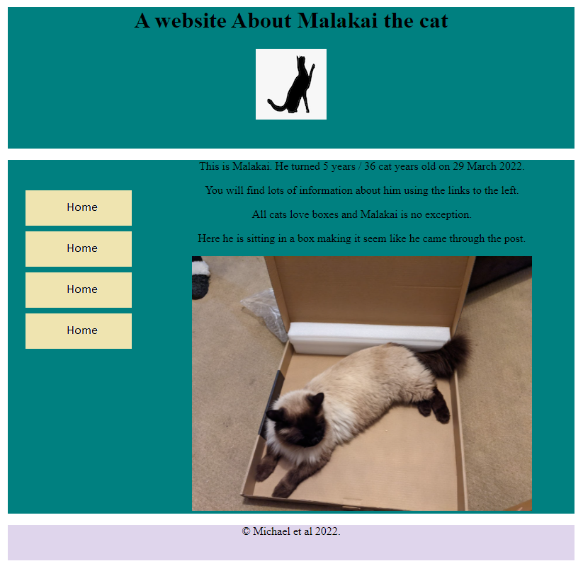

In the next meeting hopefully Sarbjeet will have the navigation sorted, and we’ll fix the spacing issue.